# Industry Supervisor Evaluation

**Instructions for completing this form**

The Professional Internship Unit provides students with an opportunity to apply and build upon knowledge and skills developed during their studies in an industry or community workplace setting. The unit aims to prepare students for transition to professional practice and careers in the current and future world of work. Your feedback as in Industry Supervisor is an important part of the unit.

Students are asked to complete Section 1.

Supervisors are asked to complete the following:

Section 2: This section confirms that the student has met the internship and workplace requirements.

Section 3: This section provides feedback to the student about their performance to support their ongoing professional development.

Section 4: Signature

If you would like to discuss this evaluation form or have any concerns about a student’s performance, please contact the Work Integrated Learning team as soon as possible at wil@swin.edu.au

## Section 1: Student details (to be completed by the student)

**Name:** S M Ragib Rezwan

**Student ID:** 103172423

**Email address:** 103172423@student.swin.edu.au

**Internship role:** Cyber Security Intern

**Organisation/Company name:** 99aupairs

## Section 2: Internship and Workplace requirements (to be completed by the supervisor)

Please note that if the student receives an unsatisfactory in this section they will fail the unit.

|  |  |  |
| --- | --- | --- |
|  | **Satisfactory** | **Unsatisfactory** |
| Completed the required hours (120-140 hours) | ☐ | ☐ |
| Adhered to company work health and safety protocols | ☐ | ☐ |
| Acted in a professional manner at all times | ☐ | ☐ |
| Attempted to engage with roles and responsibilities outlined in the internship role or project plan | ☐ | ☐ |

## Section 3: Feedback on performance (to be completed by the supervisor)

Please use the rating scale below to provide feedback on the student’s performance:

* **Exemplary:** Demonstrated capacity is beyond the specified brief and exceeds established expectations
* **Proficient:** Capacity to demonstrate a confident and skilful application of the skills and meets expectations
* **Competent:** Demonstrated minimum level of competency
* **Unsatisfactory:** Minimum level of competency is yet to be achieved

|  |  |  |  |  |
| --- | --- | --- | --- | --- |
| **Discipline-specific** | **Unsatisfactory** | **Competent** | **Proficient** | **Exemplary** |
| The student has disciplinary knowledge and skills required to complete internships tasks | ☐ | ☐ | ☐ | ☐ |
| The student has relevant technical knowledge and skills to work effectively in this field/industry | ☐ | ☐ | ☐ | ☐ |
| Comments (optional) | S M Ragib has been exceptional at being able to identity key objectives for his projects and was impressive at finding information (to support his arguments) and being able to find a way to suggest ways to mitigate risks (cyber security). | | | |

The criteria below are selected from Swinburne’s Graduate Attributes, which describe the capability of graduates to use knowledge, skills, and behaviours to contribute to society meaningfully and positively.

|  |  |  |  |  |
| --- | --- | --- | --- | --- |
| **Professional Skills** | **Unsatisfactory** | **Competent** | **Proficient** | **Exemplary** |
| **Communication Skills:** Verbal, written, visual presentation | ☐ | ☐ | ☐ | ☐ |
| **Teamwork Skills:** Collaboration, negotiation, leadership | ☐ | ☐ | ☐ | ☐ |
| **Digital Literacies:** Ability to find and use information; Ability to learn, select and use technological tools | ☐ | ☐ | ☐ | ☐ |
| Comments (optional) | S. M. Ragib’s biggest ability is to find information and share it with the team. He has been an outstanding example on great documentation and communication. He was happy to put aside his tasks to help co-workers and thus has gained a lot of respect from his peers and management. | | | |

|  |  |  |  |  |
| --- | --- | --- | --- | --- |
| **Self-Directed Learning** | **Unsatisfactory** | **Competent** | **Proficient** | **Exemplary** |
| **Reflection and Awareness:** Ability to consider contexts; drive for continual improvement; ability to articulate strengths and weaknesses | ☐ | ☐ | ☐ | ☐ |
| **Adaptability:** Ability to transition between tasks, Ability to use knowledge and deep thinking to approach new challenges | ☐ | ☐ | ☐ | ☐ |
| **Initiative:** Ability to make and lead progress; Confidence to make decisions | ☐ | ☐ | ☐ | ☐ |
| Comments (optional) | A great team member to have. S. M. Ragib gains trust and respect from others quickly. | | | |

|  |  |  |  |  |
| --- | --- | --- | --- | --- |
| **Future-Ready Skills** | **Unsatisfactory** | **Competent** | **Proficient** | **Exemplary** |
| **Problem Solving:** Solve problems with critical evaluation of emerging trends and/or data. | ☐ | ☐ | ☐ | ☐ |
| **Judgement:** Ability to consider various pieces of information to make logical, ethical and thoughtful decisions | ☐ | ☐ | ☐ | ☐ |
| **Cultural Competency:** Ability to understand, interact, and respond to ideas and people of different organisational and cultural backgrounds | ☐ | ☐ | ☐ | ☐ |
| **Organisational and Planning Skills:** Planning, time management, attention to detail, | ☐ | ☐ | ☐ | ☐ |
| Comments (optional) | The only area of improvement to drive his leadership skills is to take on the role of driving the team’s objectives. | | | |

|  |
| --- |
| **Overall feedback and suggestions for future professional development for career readiness:**  S M Ragib has been a pleasure to work with his very friendly nature and sharp mind. His attention to detail makes it easy to check his work and have productive meetings. He is helpful to others and will put his interests aside to support others and ‘learn’ new areas with them together to achieve a common goal. Ragib, not once, ended up asking for help as he was a complete self-starter who can find information or reach out to others for help. I would highly recommend Ragib to any future employer. |

## Section 4: Signature (to be completed by the supervisor)

Name: Irene Becker

Position: CEO

Signature: 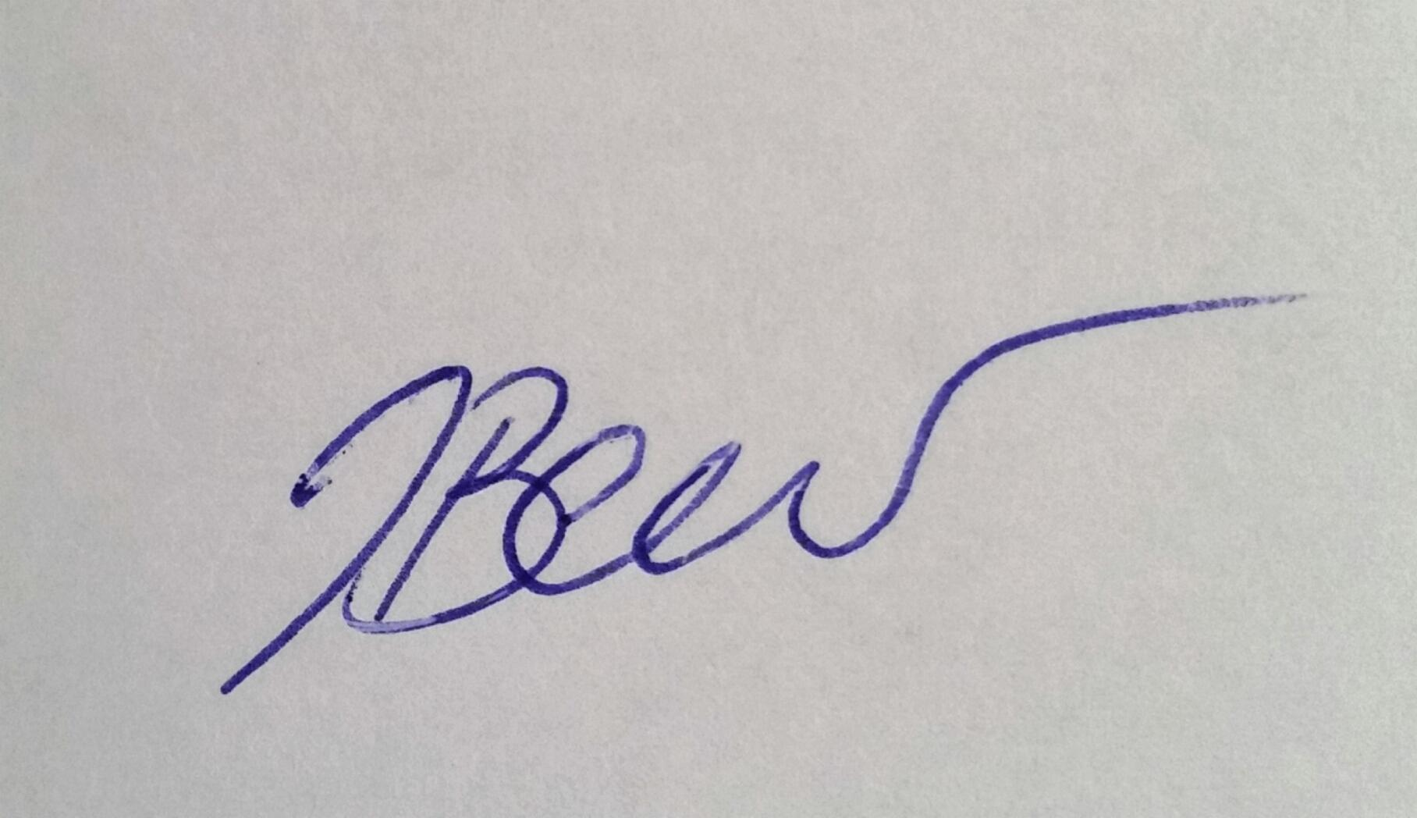

Date: 28/10/2022